**Abstract**

Telemedicine is an innovative healthcare delivery model that allows patients and doctors to communicate and receive medical consultation through online video calls. This project, called Medic Care, is a telemedicine website created using Laravel 9, Html, Css ,Bootstrap, Php, Mysql and JavaScript. It is designed specifically for patients and doctors in Bangladesh.The website offers a variety of medical services, including consultations, prescriptions, health services packages and referrals. Patients can easily schedule appointments with qualified doctors of their choice, and receive medical advice and treatment through secure and reliable video consultations. Medic Care also provides a secure online platform for patients to share their medical history and records with their doctors, ensuring continuity of care.Medic Care leverages technology to improve healthcare access and quality in Bangladesh, particularly for patients in remote areas where access to medical care is limited. By providing an efficient and flexible way for doctors to deliver healthcare services, the website also benefits healthcare providers.

Overall, Medic Care is a comprehensive telemedicine solution that uses modern technologies to connect patients and doctors in a secure and reliable manner, ultimately improving healthcare access and outcomes in Bangladesh.

**CHAPTER 1**

* 1. **Work**

Telemedicine is a modern and innovative healthcare delivery model that is gaining popularity across the globe. In light of the current pandemic and the increasing demand for virtual healthcare services, the project aims to develop a telemedicine website called Medic Care that will provide patients and doctors in Bangladesh with a reliable and efficient platform to communicate and receive medical consultations through online video calls.The website will be built using Laravel9, Php, Bootstrap, Html, css and JavaScript and will feature an easy-to-use interface that enables patients to schedule appointments, share their medical history and records, receive prescriptions and referrals, and communicate with qualified doctors via secure and reliable online video consultations. The development of Medic Care will involve designing and developing the user interface, building the backend infrastructure, and extensively testing the platform to ensure its efficiency, reliability, and security.

* 1. **Motivation**

Access to quality healthcare remains a significant challenge in Bangladesh, particularly for patients living in remote areas. Many patients in Bangladesh face difficulties in travelling long distances to see a doctor, which often results in delayed medical consultations and treatments. The current pandemic has further exacerbated this issue by making in-person consultations more difficult and riskier.

To address these challenges, the Medic Care project seeks to leverage technology to provide patients with virtual access to qualified doctors and enable them to receive medical consultations and treatments from the comfort of their homes. By offering a comprehensive telemedicine solution, Medic Care aims to bridge the gap in healthcare access and improve healthcare outcomes in Bangladesh.

Moreover, the website will benefit healthcare providers by offering them a flexible and efficient way to deliver healthcare services. By providing doctors with the ability to diagnose and treat patients remotely, Medic Care can help reduce the burden on hospitals and clinics and enable better allocation of healthcare resources.

* 1. **Objective**

. The objective of the Medic Care project is to develop a comprehensive, reliable, secure, and efficient telemedicine website that connects patients with qualified doctors in Bangladesh and improves healthcare access and quality.

The website will enable patients to schedule appointments with qualified doctors, share their medical history and records, receive medical advice, prescriptions, and referrals, all through secure and reliable online video consultations. The platform will also provide patients with a secure online portal to store and manage their medical information, ensuring continuity of care.

By providing patients with access to timely medical consultations and treatments, regardless of their location, Medic Care aims to improve healthcare outcomes in Bangladesh. Additionally, the website will benefit healthcare providers by offering them a flexible and efficient way to deliver healthcare services, ultimately leading to a more efficient and effective healthcare system in the country.

In summary, Medic Care is a comprehensive telemedicine solution that leverages technology to provide patients with virtual access to qualified doctors and enable them to receive medical consultations and treatments from the comfort of their homes. By addressing the challenges of healthcare access in Bangladesh, Medic Care aims to improve healthcare outcomes and contribute to the development of a more efficient and effective healthcare system in the country

**CHAPTER 2**

**2.1 Related Work**

Telemedicine is an increasingly popular approach to healthcare delivery that has been gaining traction around the world, including in Bangladesh. The country faces significant challenges in healthcare access and quality, particularly in rural and remote areas. As a result, telemedicine platforms have emerged as a promising solution to address these issues.

Several telemedicine initiatives have been launched in Bangladesh to provide patients with virtual access to medical consultations and treatments. Among them, "Doctorola" and "Doctime" have been successful in offering convenient and affordable healthcare services to patients in the country.

Doctorola is a telemedicine platform that enables patients to consult with qualified doctors through video consultations. This platform has been successful in providing virtual access to medical services and has helped to address the challenges of healthcare access in Bangladesh. Similarly, Doctime provides patients with access to healthcare services through an online portal, including consultations with doctors, online prescriptions, and lab test bookings.

**2.2 Scope of the problem**

Despite the success of telemedicine platforms, access to quality healthcare remains a significant challenge in Bangladesh. Many patients face difficulties travelling long distances to see a doctor, resulting in delayed medical consultations and treatments. Moreover, the current pandemic has made in-person consultations more difficult and risky.

The development of Medic Care aims to address this problem by providing a comprehensive and reliable telemedicine platform that connects patients with qualified doctors in Bangladesh. The platform will enable patients to receive medical consultations and treatments from the comfort of their homes, ensuring timely access to healthcare services regardless of their location.

Furthermore, the platform will provide healthcare providers with a flexible and efficient way to deliver healthcare services. Through the use of online video consultations and other tools, healthcare providers will be able to provide medical services to patients more effectively and efficiently. This will ultimately contribute to the development of a more efficient and effective healthcare system in Bangladesh.

The development of Medic Care has the potential to reduce the burden on physical healthcare facilities in the country, which are often overwhelmed and understaffed. By offering virtual consultations and treatments, Medic Care can help to distribute the demand for healthcare services more evenly, ensuring that patients receive the care they need when they need it.

Our Medic Care represents a significant step forward in addressing the challenges of healthcare access and quality in Bangladesh. By leveraging the latest technology and innovative approaches, Medic Care has the potential to transform the healthcare landscape in the country and improve the lives of millions of patients.

**CHAPTER 3**

**3.1Use Case Diagram**

This use case diagram helps to understand the behavior of the project from the perspective of the user end and also from admin end. Seeing this use case diagram in figure we will have an overall view of the system.

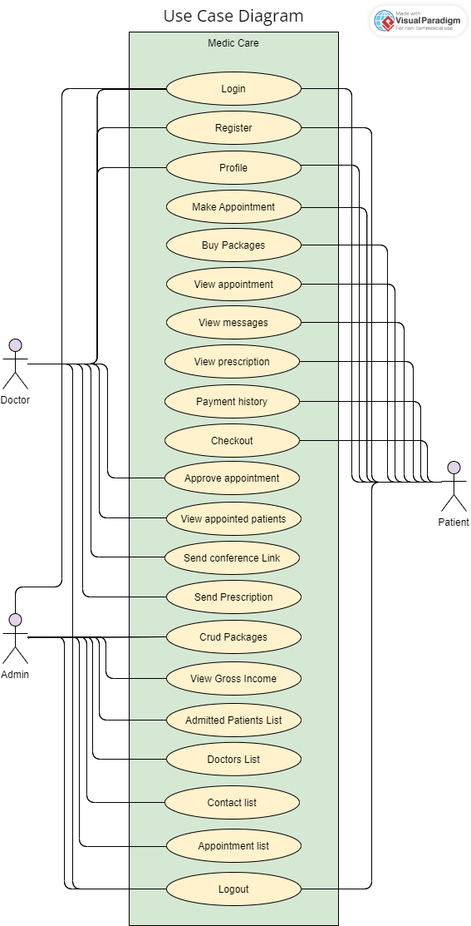

**3.2 Class diagram**

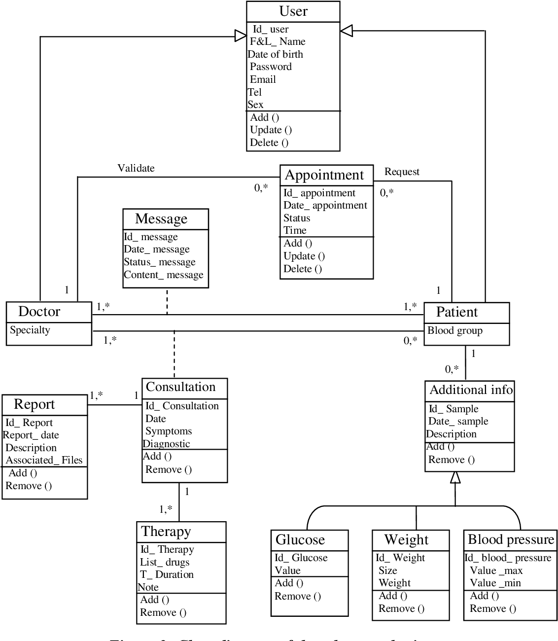

**3.3 Entity relationship diagram**

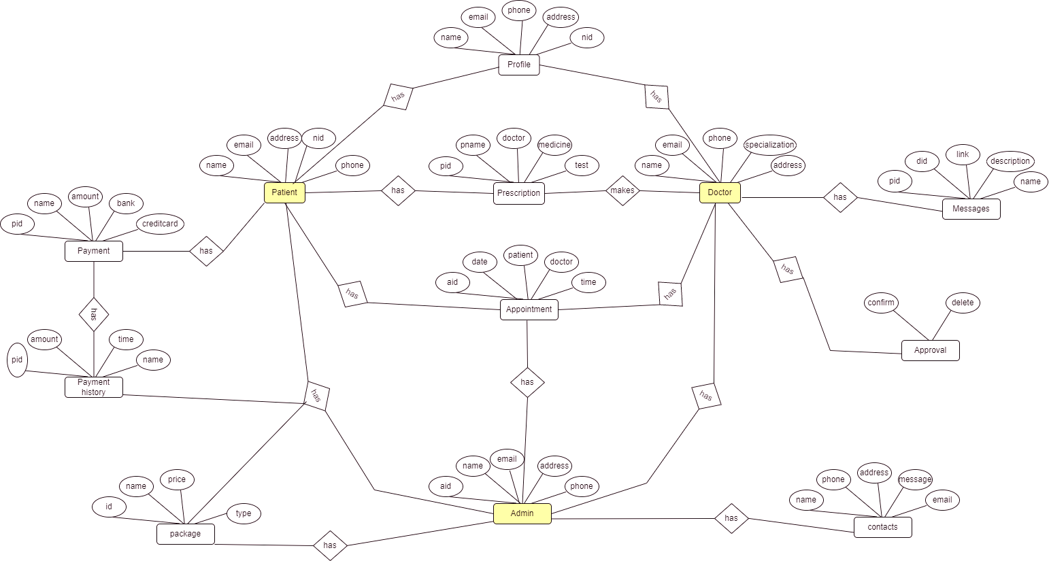

**3.4 Business process Model**

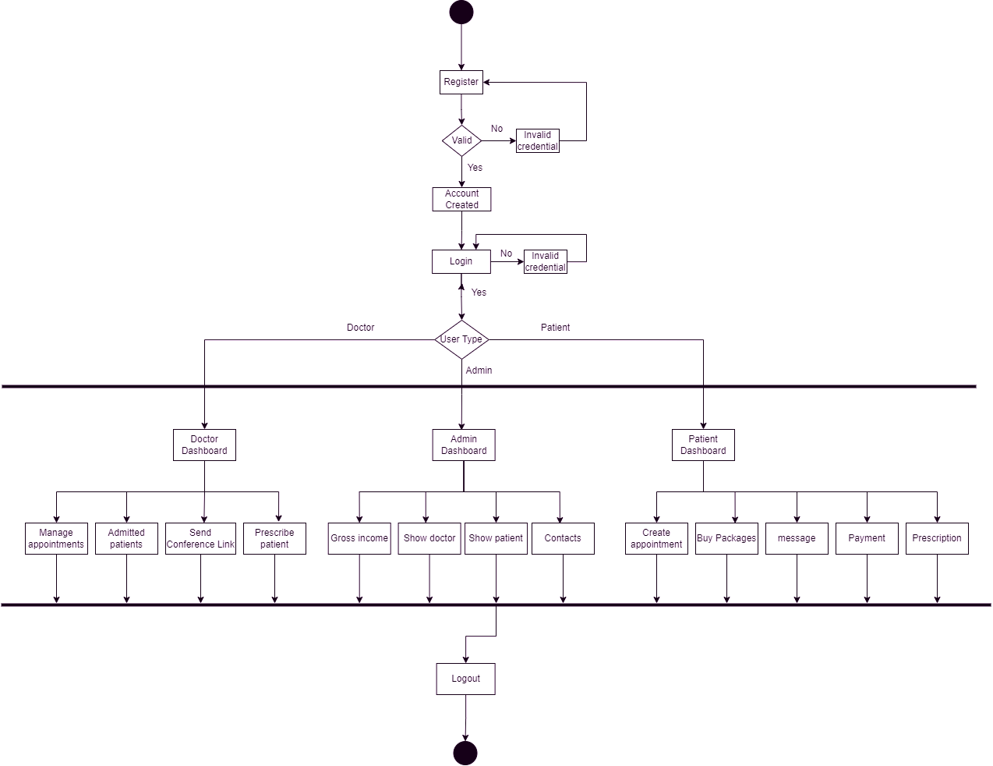

**CHAPTER 4**

**4.1 Front End Design:**

We have designed a user-friendly interface for our project. The UI is done by Figma online platform for design. For implementation we used HTML, CSS, BOOTSTRAP and for interaction with the backend we have used JavaScript.

**Home Page**

We can see our home page in from this page users can have a short knowledge of our page.

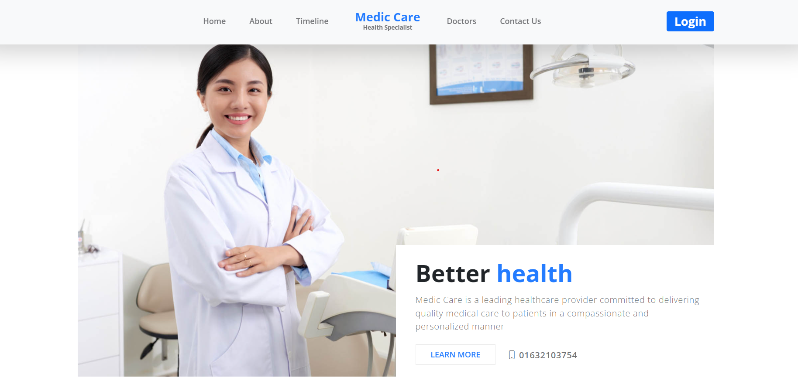

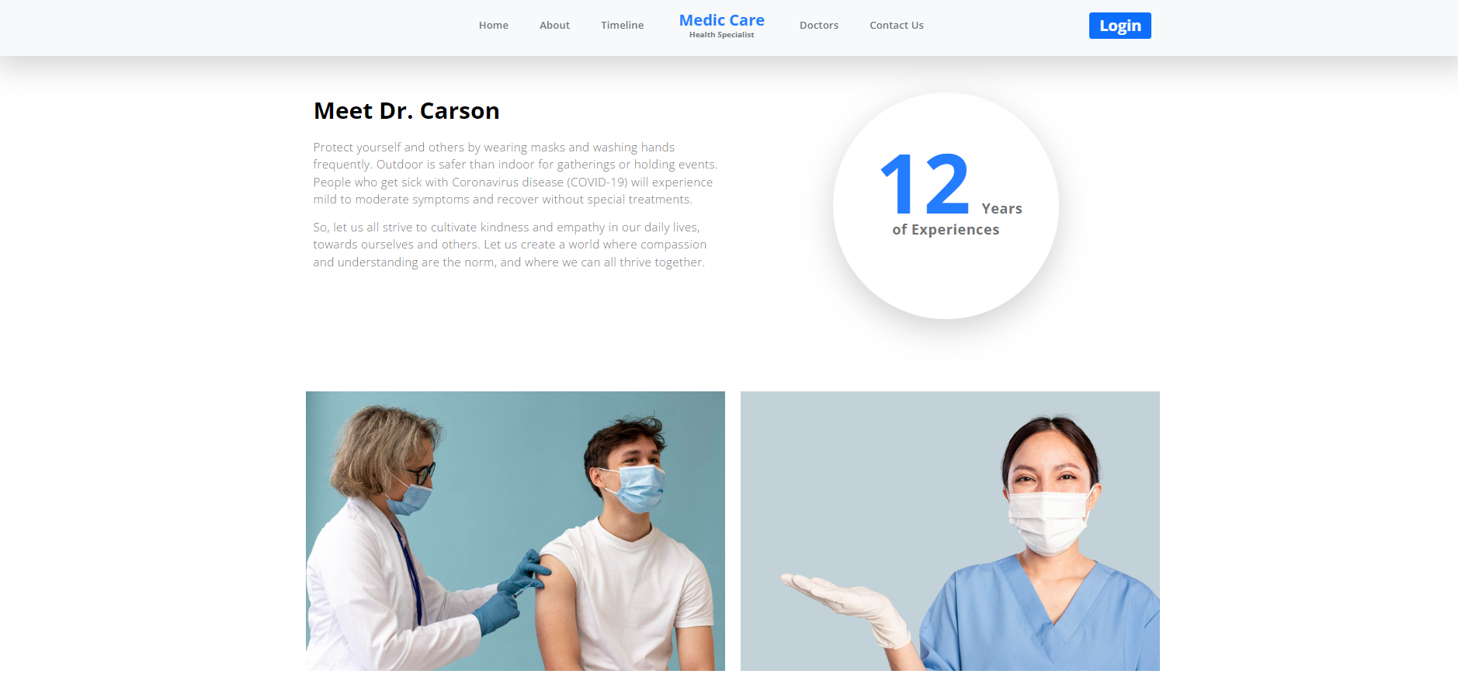

**Registration Page**

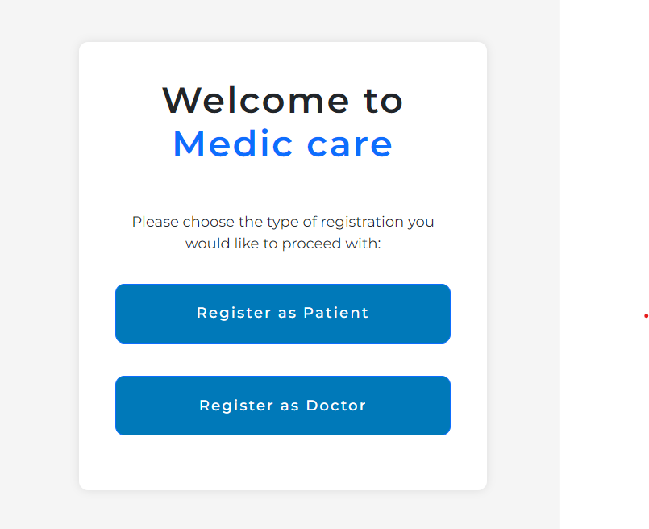

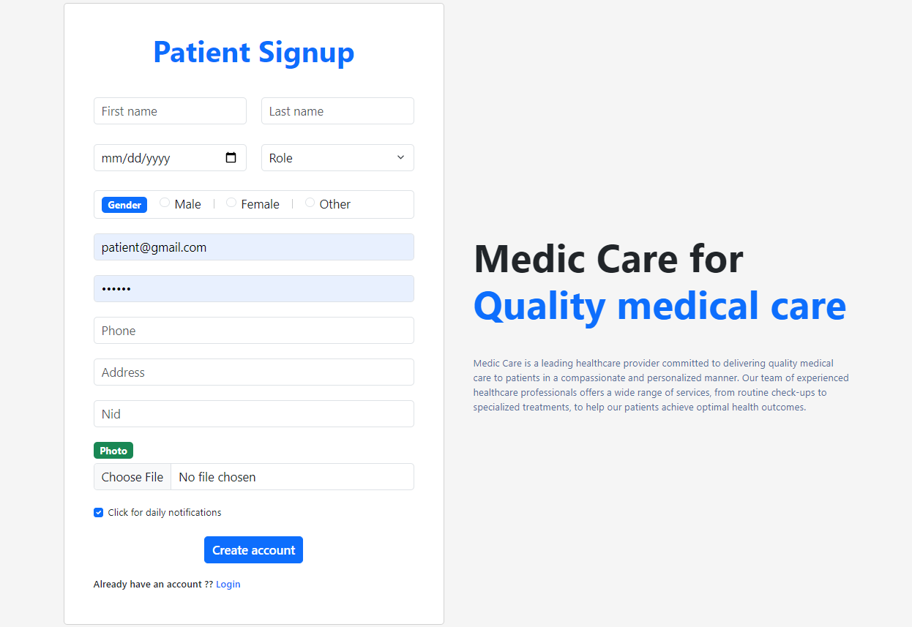

**Login Page:**

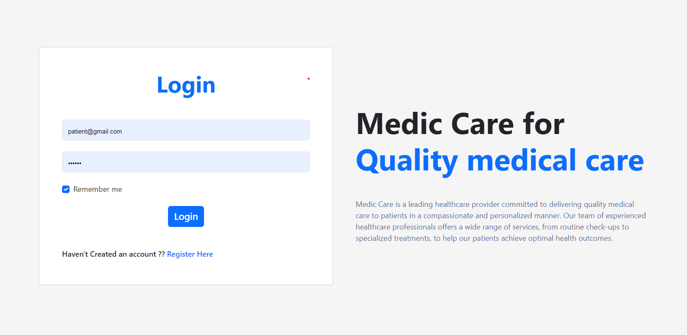

**Profile Page:**

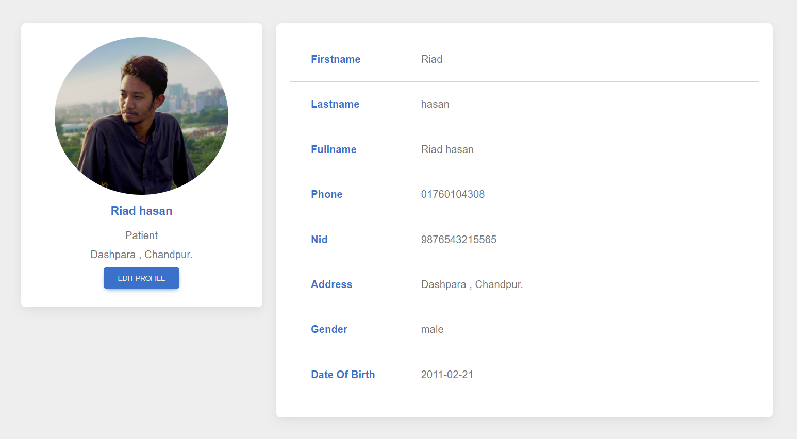

**Edit Profile page:**

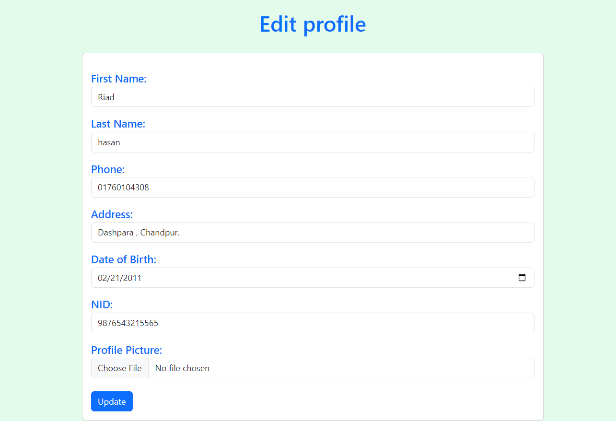

**Appointment Page:**

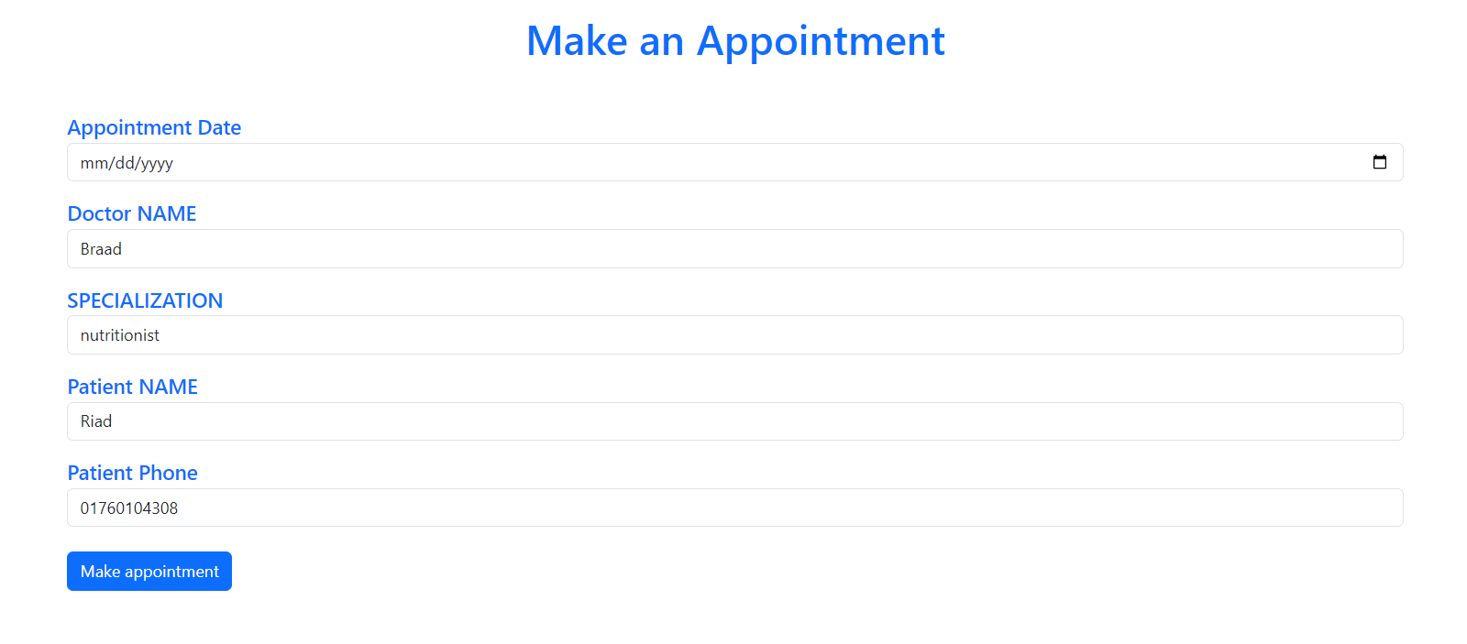

**Patient dashboard:**

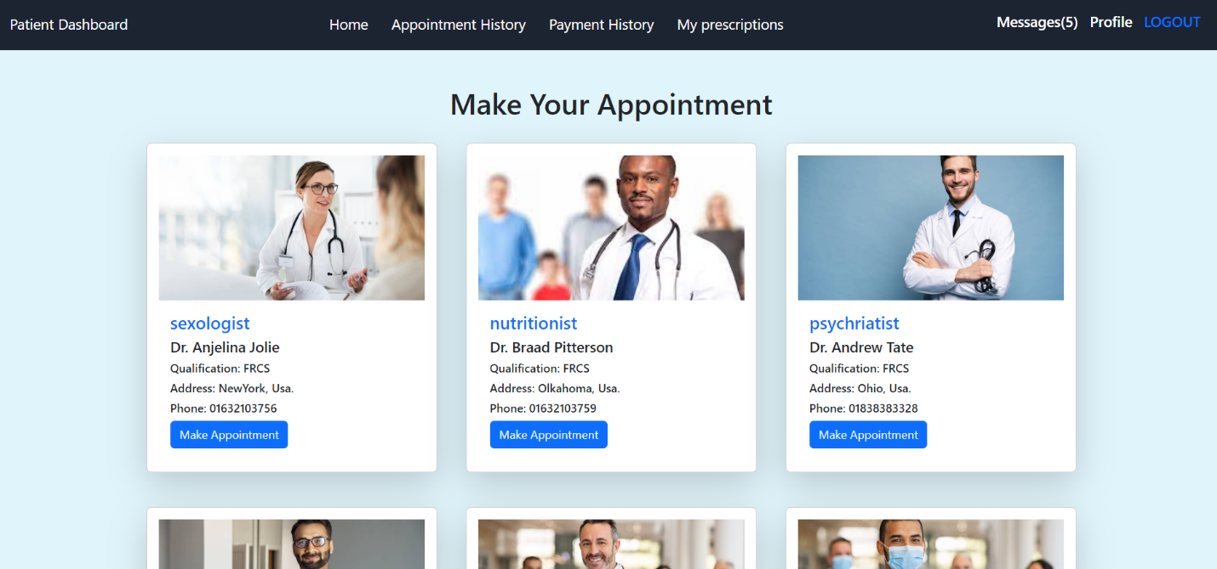

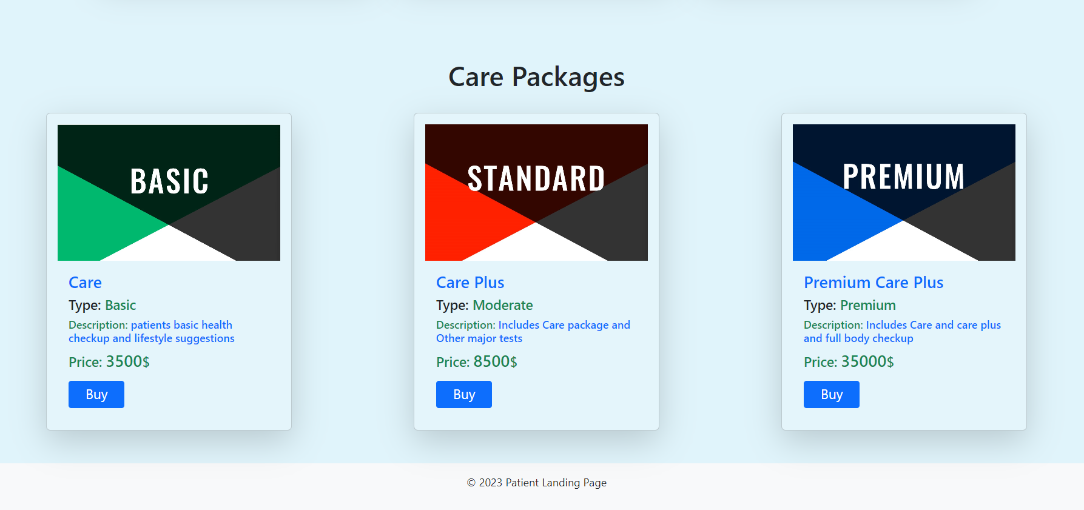

**Payment page:**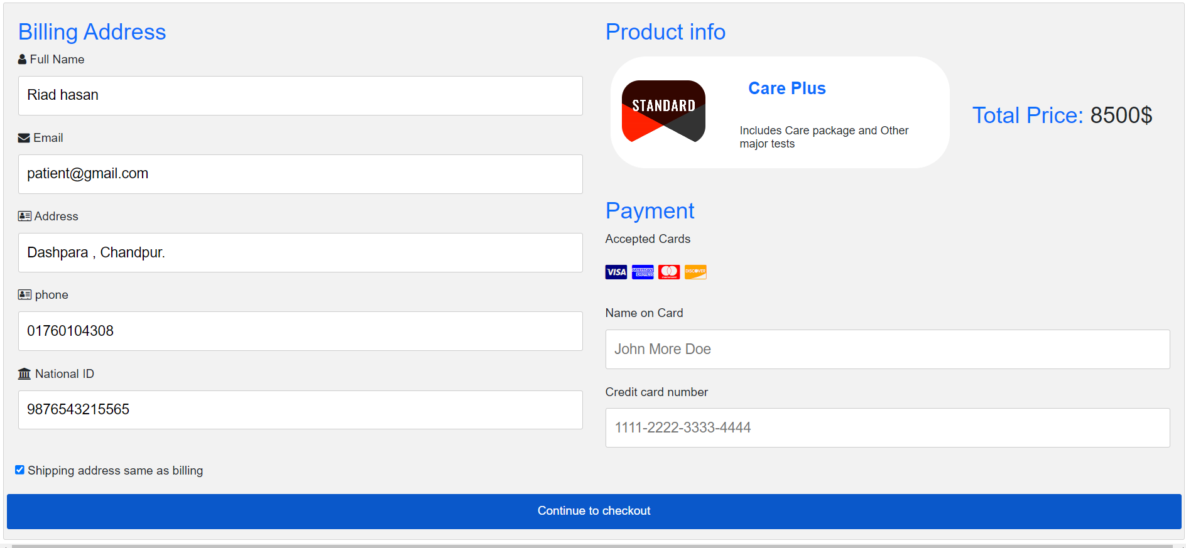

**Doctor dashboard:**

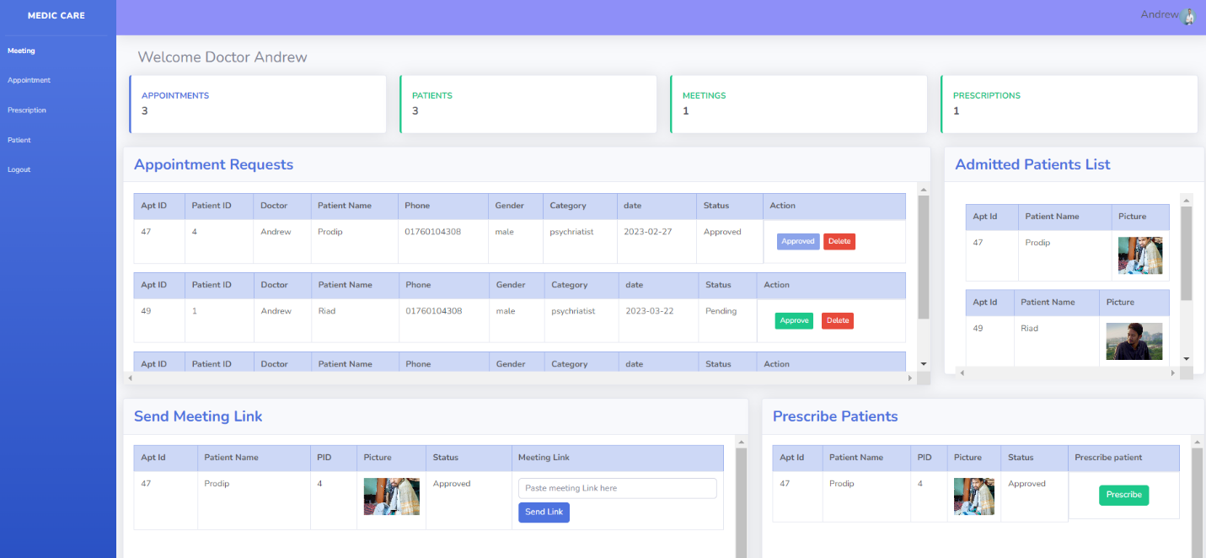

**Admin Dashboard:**

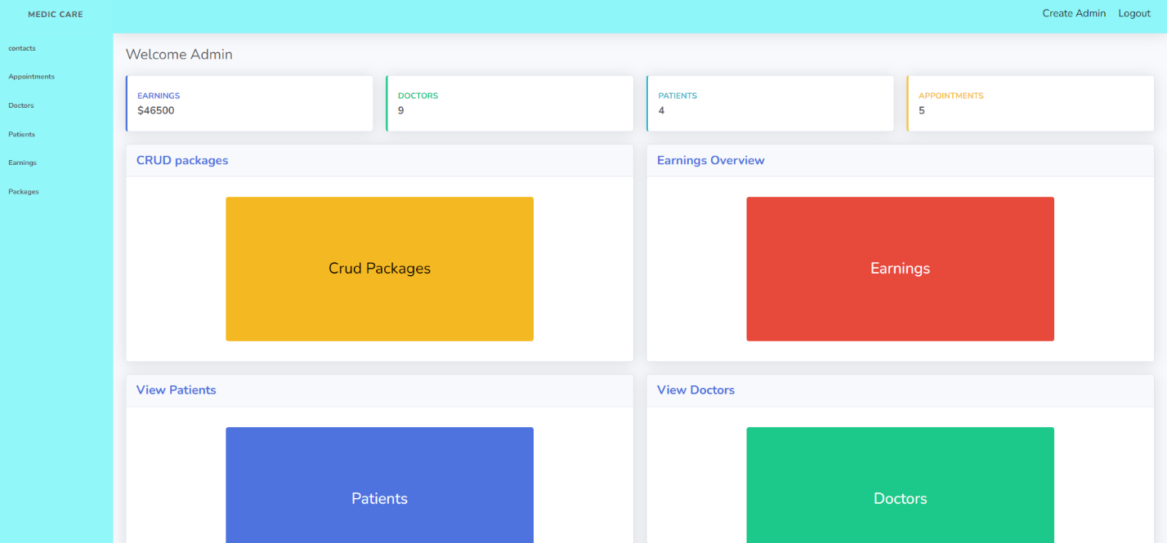

**Create Package:**

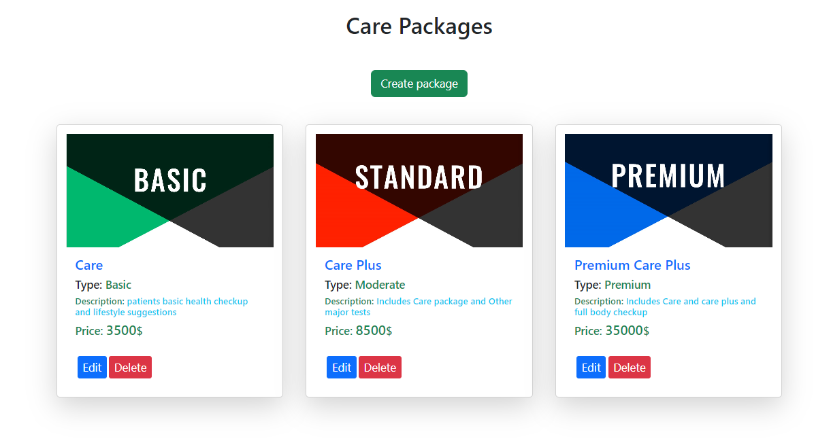

**Earning page:**

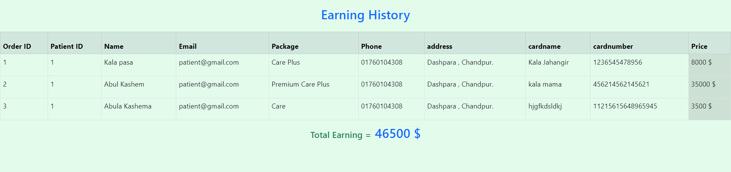

**Doctors List:**

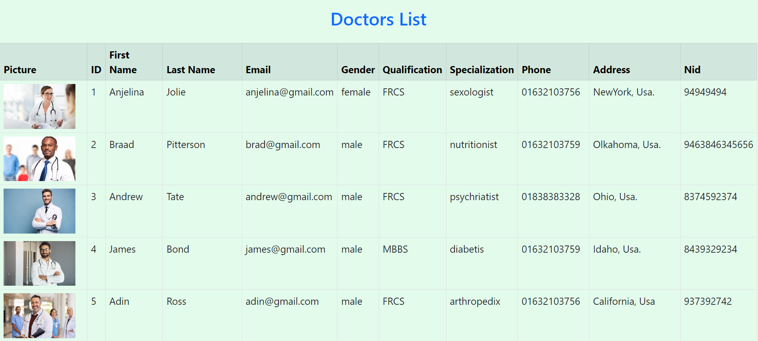

**4.2 Backend End Design:**

We have made sure that the database is secure, dependable, performant, and effective. This is why we went with PHP, Laravel which works nicely with MySQL, for the back-end. Additionally, PHP is a very stable language. And for Ide we have used visual studio code.

**Database:**

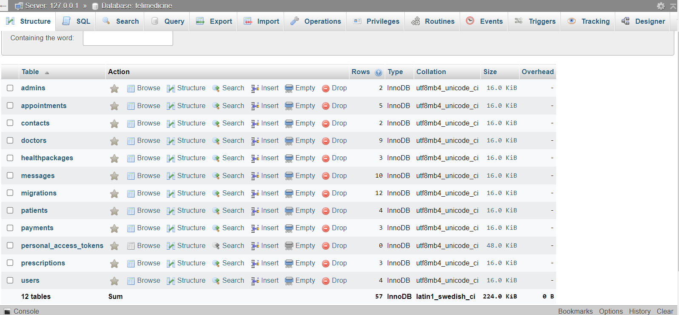

**Ide Visual Studio Code:**

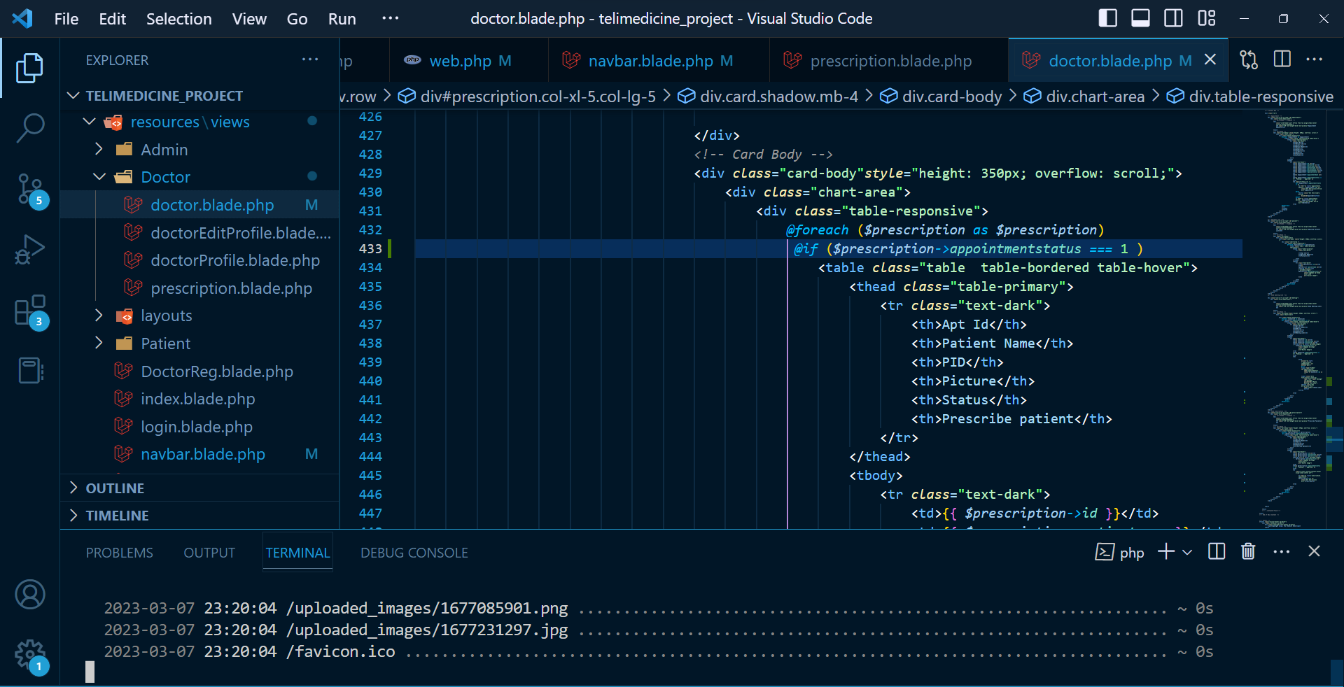

**CHAPTER 5**

**IMPLEPENTATION AND TESTING**

**5.1 Implementation of Database**

To store a large amount  of data we have tried to ensure database security as many users' personal information will be stored here. Databases have to store a huge amount of data. As many students will frequently post advertisements. To handle this data we have used MySQL[5], an open-source relational database management system. We have selected PHP[3] for back-end which goes well with MySQL.[5]

**5.2 Implementation of back-end**

Our system will have to manage a pretty good amount of user data. Fast came the safety issue. We have ensured the database security, stability, Performance, and efficiency. For this reason we choose PHP[3], Laravel[4] for the back-end which goes well with MySQL[5]. Also PHP[3] is a strongly stable language. Another reason behind choosing this is to quickly load the website.



**5.3 Implementation of Front-end design**

This is a user-friendly website. We have designed a UI using Flutter. Implementation part is made by CSS, HTML, Bootstrap, and JavaScript. This is a multiple page website. Moreover this is a responsive application. We can use it from laptops, mobile phones, tablets.

**5.4 Testing Implementation**

Only developing an application is not enough for publishing. Before publishing we have taken several tests to check the system is working properly. After checking all the possible unit tests we are now hoping our application is ready to publish. We have tested our application manually. We also did integration testing in all features.

Table 5.4.1: Test Cases

|  |  |  |  |  |  |
| --- | --- | --- | --- | --- | --- |
| No. | Test Input | Test Input | Expected  Outcome | Obtained  Outcome | Pass/Fail |
| 1 | User  Registration | User must fill the all requirement for sign up. | Popup Succession message | Popup Succession message showed | Pass |
| 2 | Form validation | Submit without filling inputs | Warning message show | Warning message shown | Pass |
| 3 | User Log In | Fill Information using correct email and password | Successfully logged in | Successfully logged in | Pass |
| 4 | User Log In | Wrong email and password provided | Incorrect email and password provided | Incorrect email and password provided | Pass |
| 5 | User Log In | Account not created | Account not exist | Account not exist | Pass |
| 6 | Appointment | Appointment creation | placed successfully | placed successfully | Pass |
| 7 | Buy package | Try to buy package | Package buy | Package bought | Pass |
| 8 | Update Profile | Change some information of user | Successfully updated | Successfully updated | Pass |
| 9 | Appointment history | Show my appointments | Show appointments | Shown Successfully | Pass |
| 10 | Payment history | Show payments | Show successfully | Shown  successfully | Pass |
| 11 | Messages | Show messages from doctors | Successfully  shown | Shown successfully | Pass |
| 12 | Approve appointment | approve | approved successfully | Approved  successfully | Pass |
| 13 | Decline appointment | Decline | Declined | Declined | Pass |
| 14 | Show conference link | Send google meet, zoom link | Sent | Sent | Pass |
| 15 | prescription | Send prescription to patient | Sent | Sent | Pass |
| 16 | View gross income | Show total income | Showed | Showed | Pass |
| 17 | View admitted patients | Show total number of patients taking service | showed | showed | Pass |
| 18 | View doctors | Show all doctors | showed | showed | pass |
| 19 | contacts | Send contact to website | sent | sent | pass |

**5.5 Test Results and Reports**

The system has passed several tests and outcomes with a satisfactory result. After seeing those results we can publish this application for students. Bug is a part of application as now we test the application manually there can be some issues which are hopefully fixed. Further more the application is ready to publish for benefit.

**CHAPTER 6**

**6.1 Impact on Society And Environment**

Medic Care is a revolutionary platform that has the potential to transform healthcare in Bangladesh. With its virtual consultations and treatments, it promises to improve healthcare access and quality, address healthcare inequality, create job opportunities, and promote environmentally sustainable healthcare practices. These benefits are expected to have a significant positive impact on both society and the environment in Bangladesh.

From a societal perspective, Medic Care can enhance health outcomes by providing virtual access to high-quality medical care for patients. This is especially important for people living in remote or underserved areas who may not have easy access to physical healthcare facilities. By offering virtual consultations and treatments, patients can receive medical attention from the comfort of their own homes, without the need to travel long distances or wait in crowded waiting rooms. This can lead to better health outcomes, increased patient satisfaction, and reduced healthcare costs.

In addition, Medic Care can create new job opportunities for healthcare professionals, which is a crucial factor in addressing the healthcare professional shortage in Bangladesh. As the platform grows, it is expected to generate more jobs, contributing to the development of the healthcare workforce in the country.

From an environmental perspective, Medic Care can have a positive impact by reducing greenhouse gas emissions and air pollution linked to transportation. By offering virtual consultations and treatments, patients no longer need to travel long distances to receive medical services. This can lead to a significant reduction in transportation-related emissions and air pollution. Furthermore, Medic Care can reduce the amount of waste generated by traditional healthcare facilities. Single-use medical supplies and equipment create significant waste, and by providing virtual consultations and treatments, Medic Care can reduce this waste and encourage eco-friendly healthcare practices.

In summary, Medic Care's creation is expected to have a considerable positive impact on both society and the environment in Bangladesh. By providing virtual access to medical consultations and treatments, it can enhance healthcare access and quality, address healthcare inequality, create job opportunities, and promote environmentally sustainable healthcare practices. This is a significant step forward for the healthcare sector in Bangladesh and has the potential to be a model for other countries.

**CHAPTER 7**

**7.1 Conclusion**

In conclusion, Medic Care is an innovative telemedicine platform that has the potential to revolutionize healthcare in Bangladesh. The platform offers virtual consultations and treatments that are convenient, efficient, and accessible to all, regardless of their location or economic status. It has the potential to improve healthcare access and quality, address healthcare inequality, create job opportunities, and promote environmentally sustainable healthcare practices. With Medic Care, patients can receive high-quality medical care without the need to travel long distances, wait in crowded waiting rooms, or spend money on transportation. Healthcare professionals can also benefit from this platform by reaching out to patients and delivering their services online. The advantages of Medic Care are expected to have a significant and positive impact on both society and the environment in Bangladesh.

**7.1 Future Scope:**

There is enormous potential for Medic Care to grow and expand in the future. In the short term, the platform could develop additional features such as real-time monitoring of patients' health conditions, electronic prescription, and NFC payment options. This would improve the efficiency of the platform and provide additional benefits to patients and healthcare providers.

In the long term, the platform could also integrate with other technologies such as machine learning and artificial intelligence to provide personalized treatment recommendations based on patients' medical history and current health condition. The platform could also expand to include other healthcare services such as mental health support, physiotherapy, and nutrition counselling.

Moreover, the platform could be extended to other countries where healthcare access is limited, making a significant contribution to global healthcare. As the platform expands, it has the potential to generate more jobs and promote economic development in the healthcare sector.

In conclusion, Medic Care is a promising telemedicine platform with a bright future. It has the potential to transform healthcare in Bangladesh and beyond, and we are excited to see the impact it will have on the world.